***Assignment -5***

***Andrew John***

***18BEC1278***

* **Create a web dashboard to take user input for scheduling the pump controller (date & time). store the data in the Cloudant DB. You can use Form Nodes in dashboard nodes to take user input.**

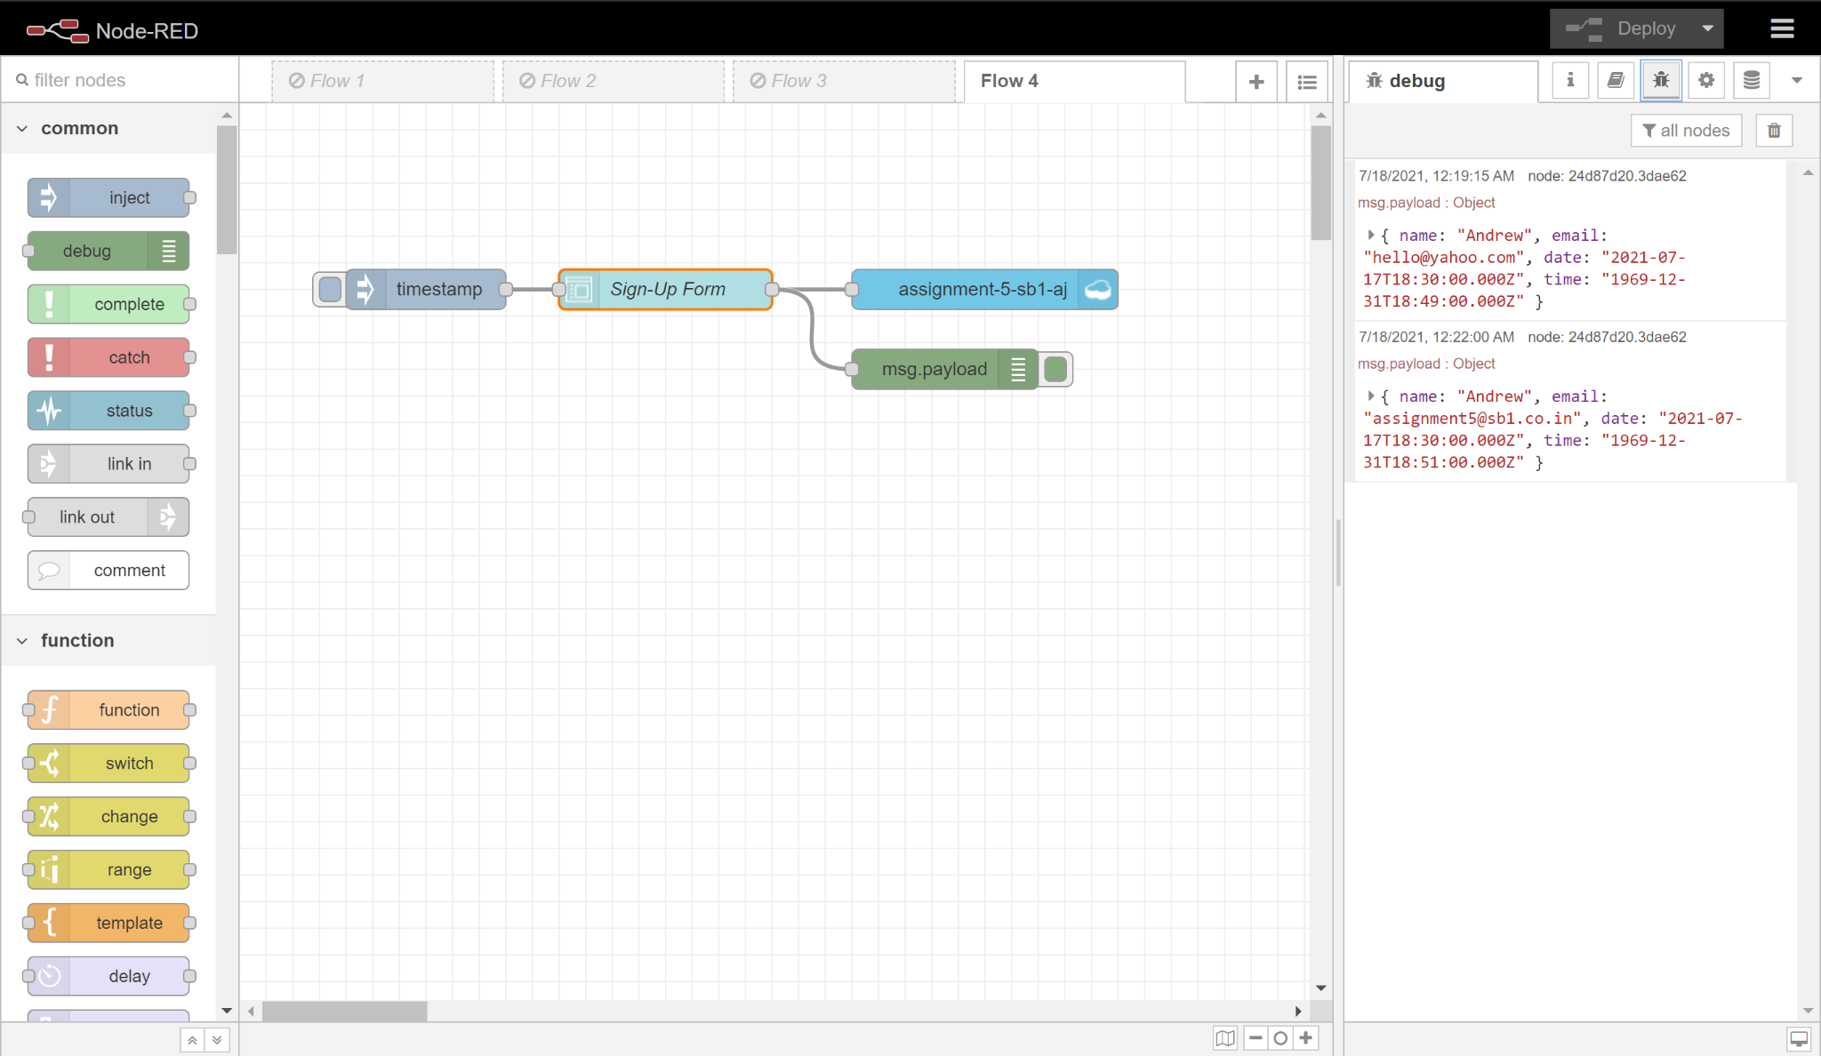

*Fig-1: Node-RED Flow*

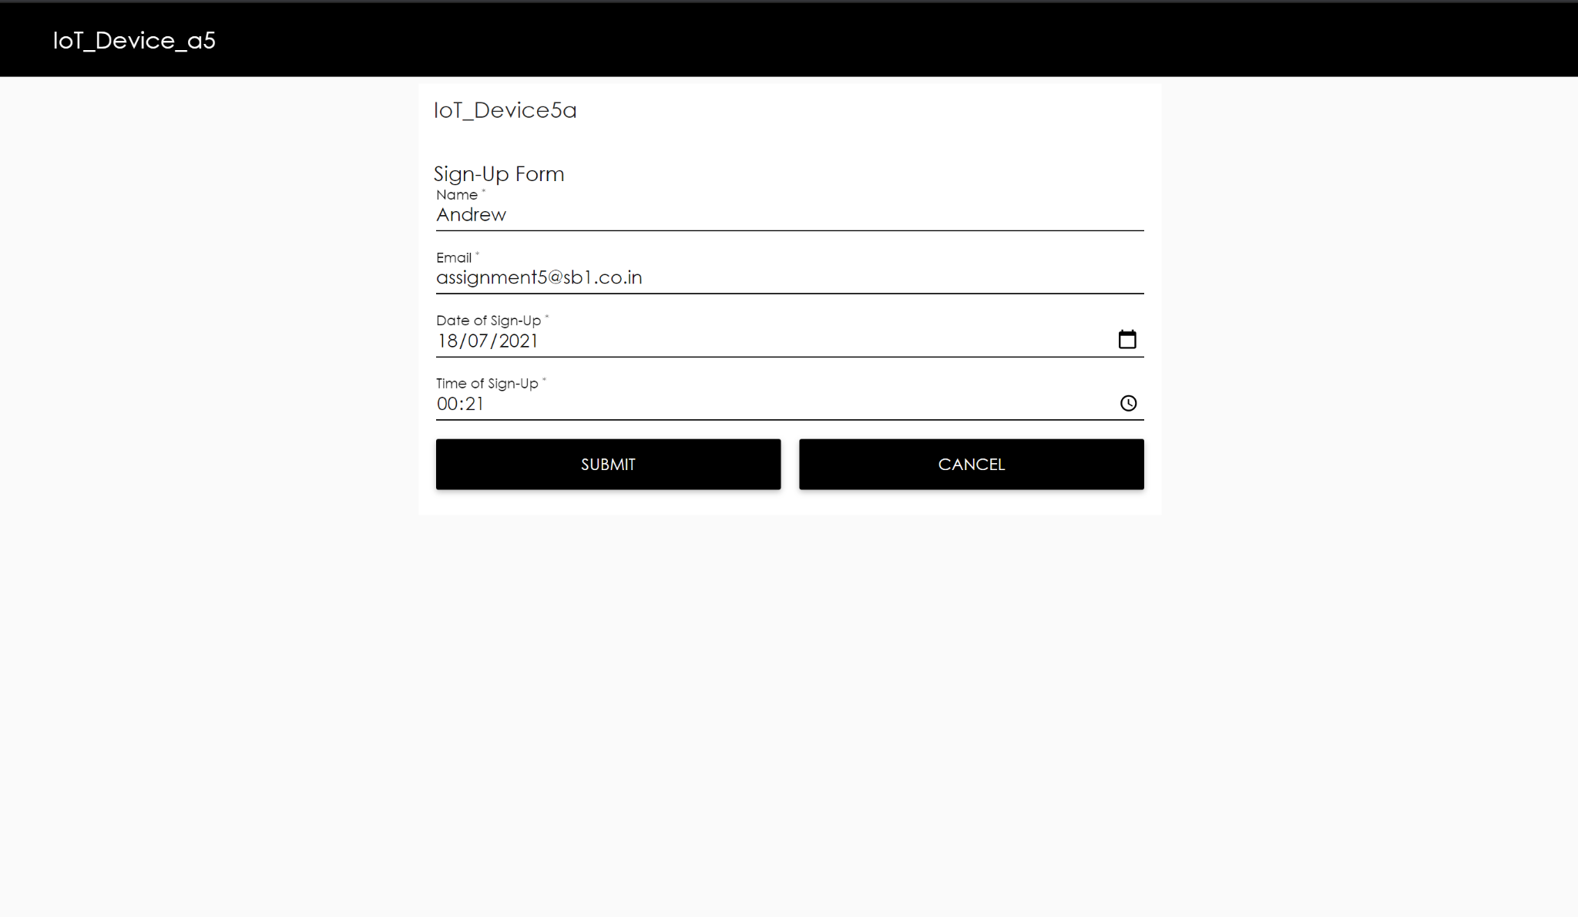

*Fig-2: Node-RED UI Dashboard*

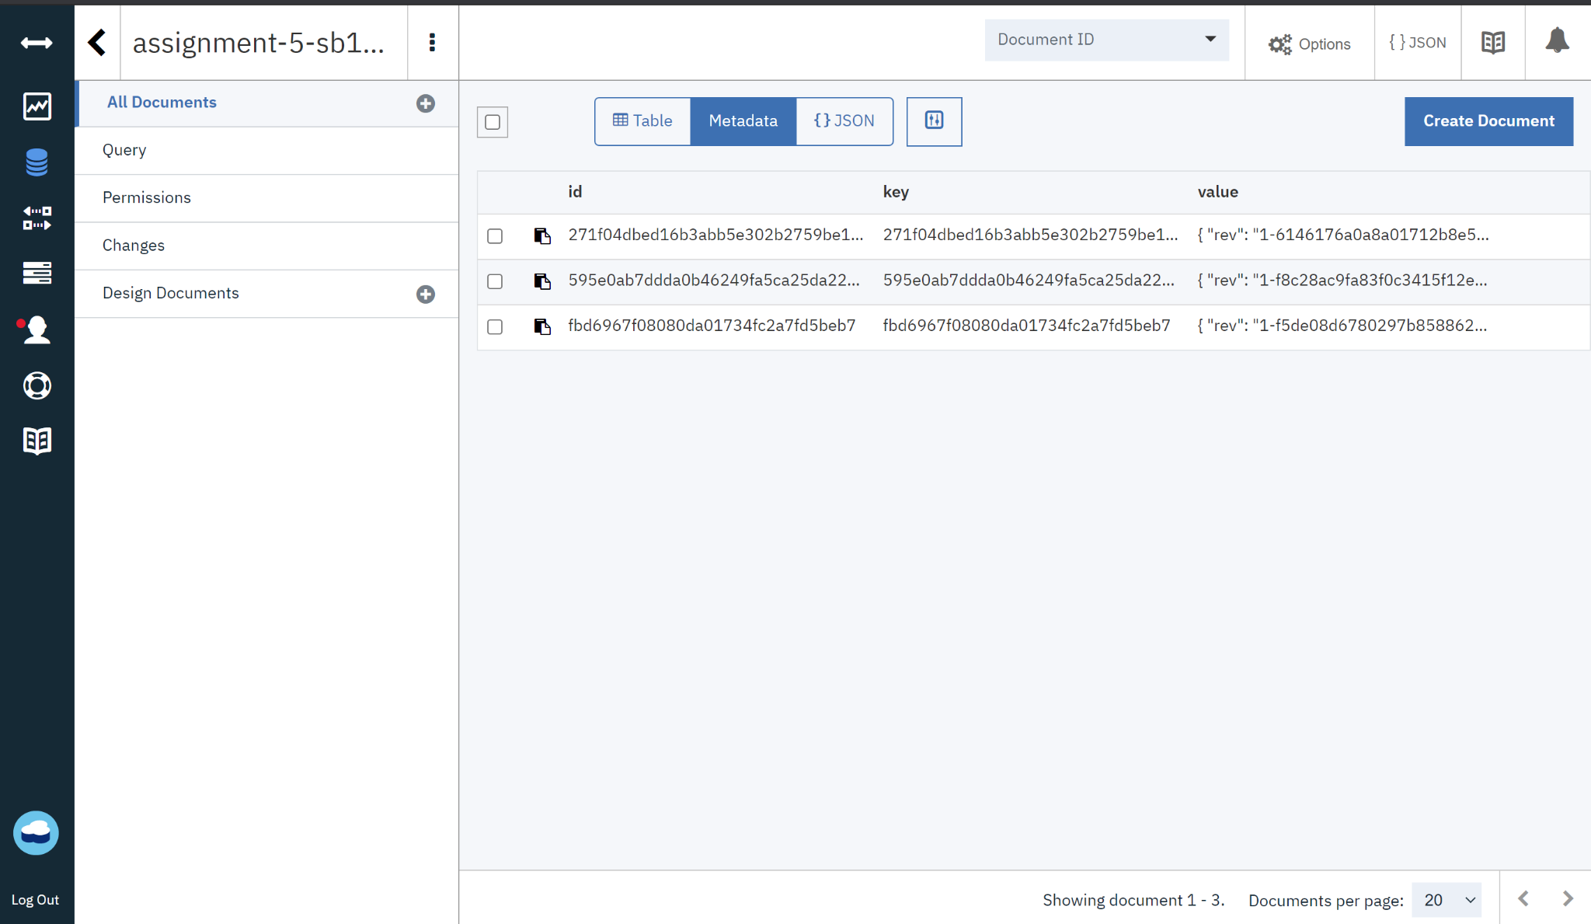

*Fig-3: Cloudant DB*

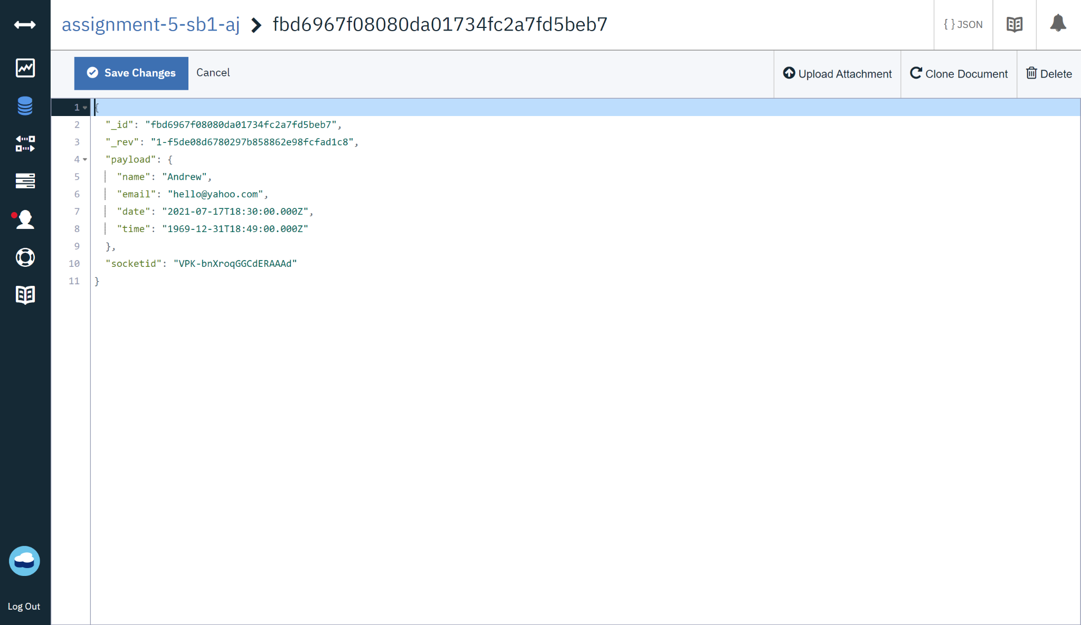

*Fig-4: Recently received info in json format*